Exercise 17
1. Find and list the ids and spouse names of all employees who are married.
SELECT emp_id, spouse_name
FROM employee_data
WHERE spouse_name IS NOT NULL
AND spouse_name <> ''
ORDER BY emp_id;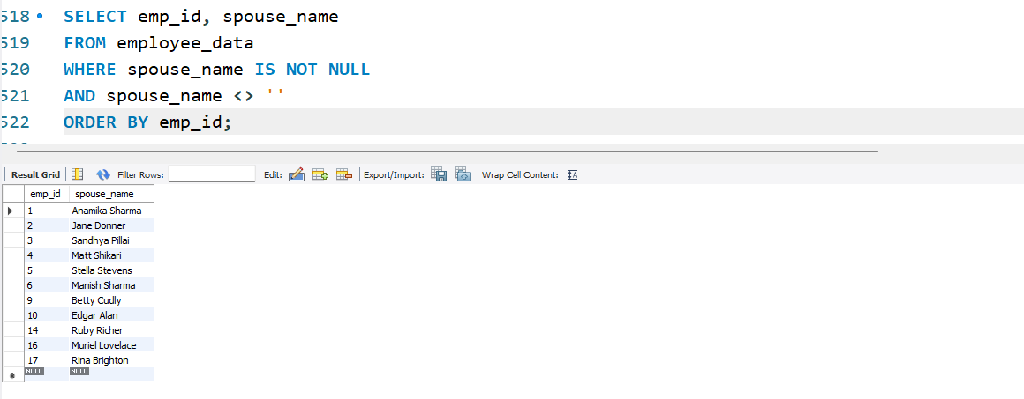

2. Change the above so that the display is sorted on spouse names.
SELECT emp_id, spouse_name
FROM employee_data
WHERE spouse_name IS NOT NULL
AND spouse_name <> ''
ORDER BY spouse_name;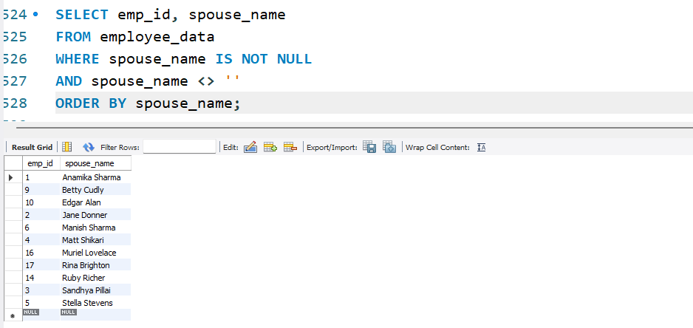

3. How many employees are there?
SELECT COUNT(*) FROM employee_per;
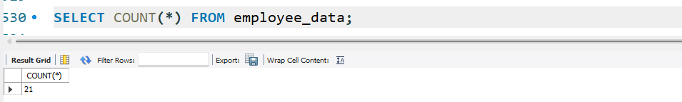

4. How many of your employees are married and unmarried (female)?
Married
SELECT COUNT(*) AS married_count
FROM employee_data
WHERE spouse_name IS NOT NULL
AND spouse_name <> '';
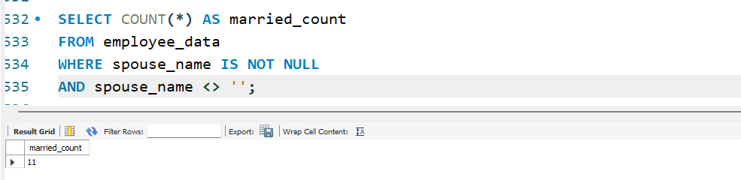

Unmarried
SELECT COUNT(*) AS unmarried_female_count
FROM employee_data
WHERE spouse_name IS NULL
AND f_name IN ('Mary','Anamika','Monica','Shahida');
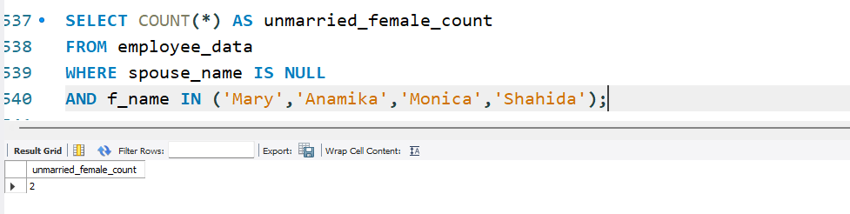
5. Make unique groups of children and find the number in each group.
SELECT children, COUNT(*) FROM employee_per GROUP BY children;
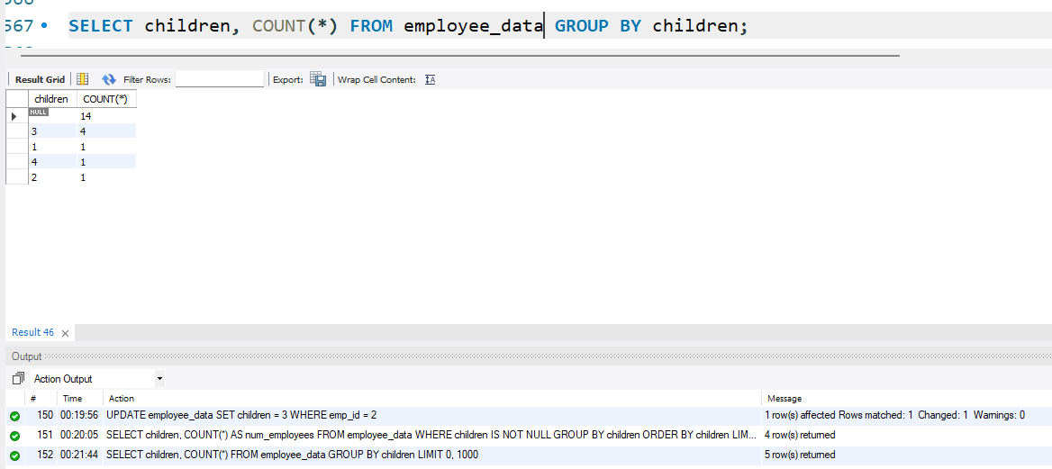
6. Sort the display with the group having maximum children at the top.
SELECT children, COUNT(*) AS num_employees
FROM employee_data
WHERE children IS NOT NULL
GROUP BY children
ORDER BY children; 